Exp No: 2
GENERATION OF SQUARE WAVE USING PROTEUS
AIM:
To write an assembly language program to Generate square wave using AT89C51.

SOFTWARE REQUIRED:
• Proteus 8 software.

PROGRAM
ORG 0000H
UP: SETB P2.0
ACALL DELAY
CLR P2.0
ACALL DELAY
SJMP UP
DELAY: MOV R4,#35
H1:MOV R3,#255
H2:DJNZ R3,H2
DJNZ R4,H1
RET
END
CIRCUIT DIAGRAM:
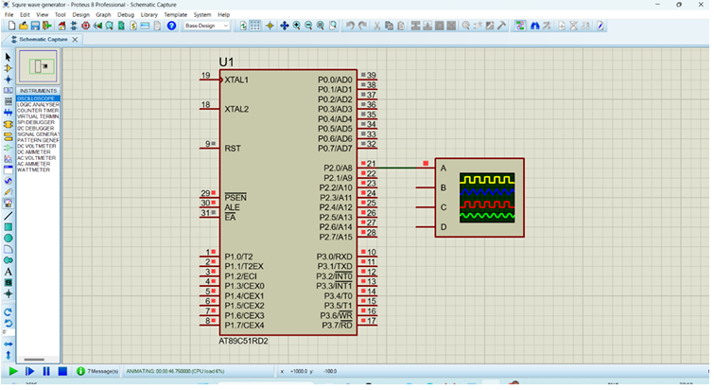
OUTPUT:
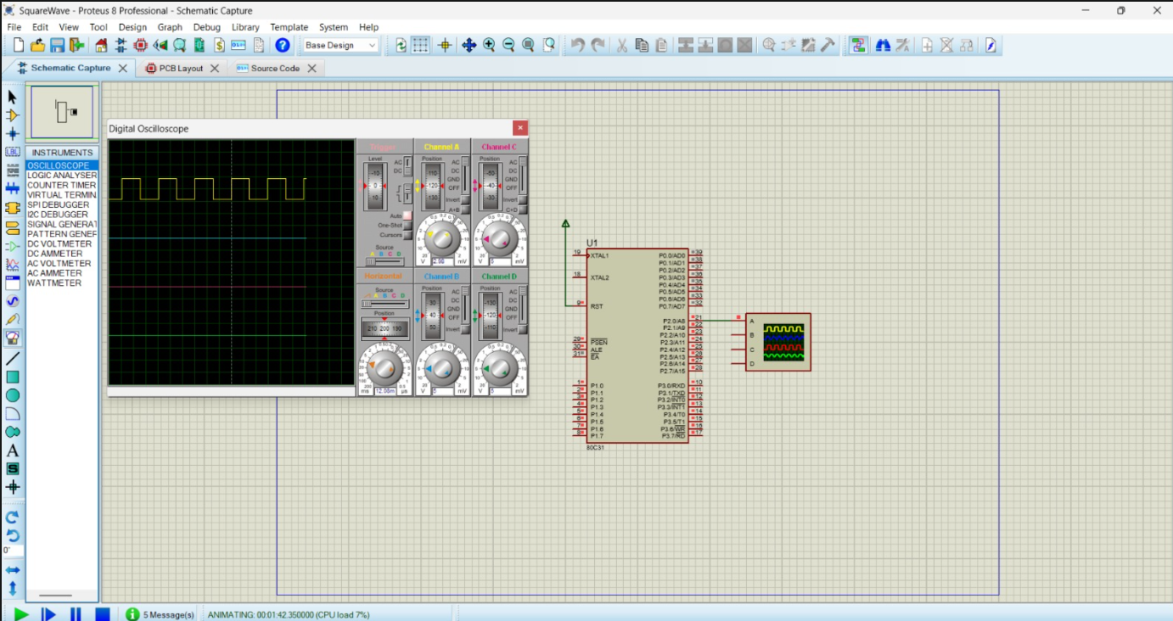
RESULT:
Thus the program has been successfully verified and executed.

